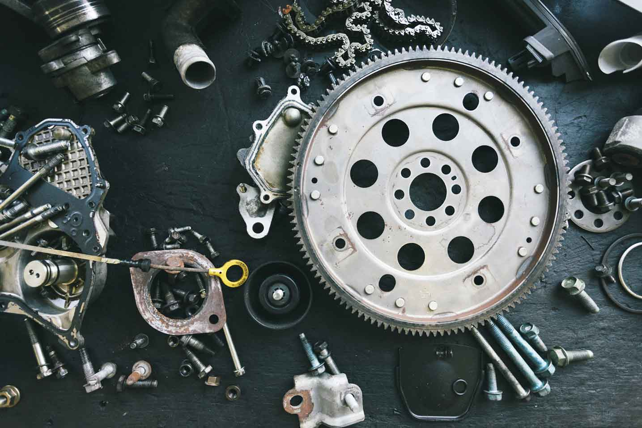­­­­­

|  |  |
| --- | --- |
|  |  |



Process Definition

Document

Automation for Verify Account Positions for ACME Systems Inc.

Date: 30-08-2025

Process Design Document History

|  |  |  |  |  |  |  |  |
| --- | --- | --- | --- | --- | --- | --- | --- |
| Date | Version | Role | Name | Organization | Function | Comments | |
| 30.08.2025 | **1.0** | **Author** | **Amr Ayman** | **Raya IT** | **BA** | | **Creation v1.0** |
|  |  |  |  |  |  | |  |

Table of Contents

1. objective 5

1.1 Purpose 5

1.2 Objectives 5

1.2.1 Business Objectives and Benefits 5

1.3 Key Contacts 6

2. current process 7

2.1 Process Overview 7

2.2 Standard Of Metrics 7

3. Business rules 8

4. detailed process steps – As is 9

4.1 High Level process diagram 9

4.2 Detailed Process map 10

4.3 Detailed Process Steps 11

5. to be process (proposed solution) 16

6. In – scope 17

7. out of – scope 17

8. non – process requirements 18

8.1 Systems 18

8.2 Reporting 18

8.3 Archiving 18

9. appendix 19

9.1 Open Questions 19

9.2 Escalations 19

# objective



## Purpose

**The Process Design Document describes the business processes chosen for automation using UiPath Robotic Process Automation (RPA) technology.**

**The document describes the sequence of steps performed as part of the process, the conditions and rules of the process prior to automation.**

## Objectives

**The Automation of the full process of Verify Account Positions Task in the ACME systems, reducing the Human interaction to zero, the system will operate seamlessly throughout the two systems of ACME system 1 and system 3, delivering faster processing , reduce the duration time of time-consuming activities and improving departments’ overall performance and reliability.**

### Business Objectives and Benefits

|  |  |
| --- | --- |
| Objectives | Expected Benifits |
| Automate the full Verify Account Positions process across ACME System 1 and System 2 | **Eliminate manual intervention, ensuring end-to-end seamless execution.** |
| Reduce human interaction to zero | **Minimize errors from manual handling, improve compliance and accuracy** |
| Accelerate processing speed of verification tasks | **Shorten overall task cycle time, enabling faster turnaround for stakeholders** |
| Reduce duration of time-consuming activities | **Free up staff capacity for higher-value activities, leading to productivity gains** |
| Improve overall department performance | **Standardized processes, ensuring consistency and scalability** |
| Increasing system reliability through automation | **Lower risk of process failure, improve trust in system outputs** |
| Ensure smooth integration across both ACME systems | **Create a unified workflow with fewer exceptions and reduced rework** |
| Support continuous operations with minimal downtime | **Enhance operational efficiency and customer satisfaction** |

## Key Contacts

|  |  |  |  |
| --- | --- | --- | --- |
| Role | Name | Contact Details (email, phone number) | Notes |
| Business Analyst | **Eng. Amr Ayman** | **amr@gmail.com** |  |
| SME | **Eng. Mohamed Mesbah** | **M.Mesbah@gmail.com** | **Contact for questions, details, approvals** |

# current process



## Process Overview

**The Verify Account Positions task is currently performed manually across ACME System 1 and ACME System 3. Staff must log in to both systems, extract account data, and reconcile positions by cross-checking balances and transactions. The process involves repetitive steps such as validating entries, and documenting mismatches.**

**Due to the high level of manual intervention, the task is time-consuming, error-prone, and dependent on staff availability, often leading to delays in verification, inconsistent outputs, and operational inefficiencies. Additionally, manual handling increases the risk of overlooking discrepancies, requiring additional rework and cross-departmental follow-ups.**

## Standard Of Metrics

**General information about the process selected for RPA, prior to automation:**

|  |  |
| --- | --- |
| AS IS Process Details | |
| Item | **Description/Answer** |
| Process Full Name | **Verify Account Positions** |
| Function | **Accounts** |
| Department | **Accounts** |
| Short Description (operation, activity, outcome) | **Check all transactions for every client for every work item in the 2 systems 1 and 3 , if match complete the task, else reject.** |
| Process schedule and frequency | **Daily, Monday to Friday, 9 am – 6 pm** |
| # of items process / month | **~4500** |
| Average handling time per item | **4 min** |
| Peak Period (s) | **End of month, usually from 20th to 28th day of each month** |
| # of FTEs supporting this activity | **2** |
| Level of Exception rate | **10%** |
| Input Data | **Client ID, Client Account Number, Amount** |
| Output Data | **Account Amount MatchorNot , Email to user** |
| ROI | **Reduce the processing time by 75% and FTE to zero** |

# Business rules

|  |  |
| --- | --- |
| Business Rule | Description |
| BR-01 | **Account data must be retrieved from both ACME System 1 and ACME System 3 for the same Work Item.** |
| BR-02 | **Each account in System 1 must have a corresponding account in System 3.** |
| BR-03 | **All transactions within the reporting period must align between both systems.** |
| BR-04 | **The User Must have accessibility on modifying the account, either, request access** |

# detailed process steps – As is



## High Level process diagram

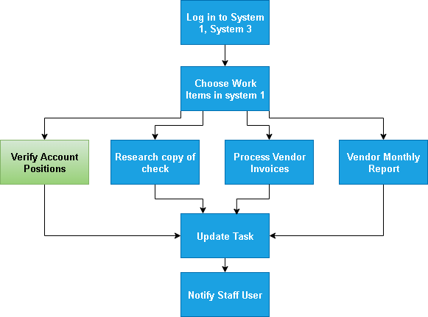

## 4.2 Detailed Process map

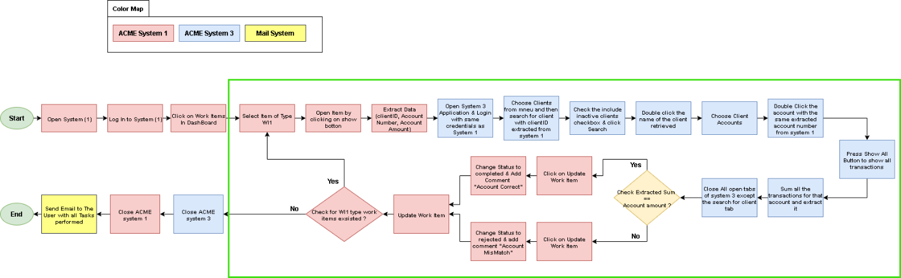**This section contains process maps contributing to a better understanding of how the process is performed pre-automation.**

|  |  |  |  |  |  |
| --- | --- | --- | --- | --- | --- |
| Step | Short Description | | | | |
| 1.1 | Open ACME system 1 web application | | | | |
| 1.2 | Log into system 1with credentials | | | | |
| 1.3 | Click on Work items in menu to display all work items | | | | |
| 1.4 | **For Each Work** Item of type WI1 perform the following steps | | | | |
| 1.4.A | Open Work item by clicking on the show button with icon (search) | | | | |
| 1.4.B | Extract data like (ClientID, Account Number, account Amount) to Save for upcoming Operations | | | | |
| 1.4.C | Open system 3 desktop application and login with same credentials as system 1 | | | | |
| 1.4.D | Choose clients from menu and then search for the client with ClientID extracted from system 1 | | | | |
| 1.4.E | Check the inactive clients checkbox and click search | | | | |
| 1.4.F | Double click on the name of the client retrieved | | | | |
| 1.4.G | Choose client accounts button | | | | |
| 1.4.H | Double click the account with the same extracted account number from system 1 | | | | |
| 1.4.I | Press Show All Button to show all transactions for client account | | | | |
| 1.4.J | Sum all the transactions for that account and extract it | | | | |
| 1.4.K | Close all tabs of system 3 except the search for client tab | | | | |
| 1.4.L | Check Extracted Sum == Account amount ? | | | | |
| Yes | | | **No** | | |
| 1.4.L-Yes_1 | Click on Update Work item Button | | **1.4.L-No_1** | | Click on Update Work item Button |
| 1.4.L-Yes_2 | Change status to completed & add comment  “Account Correct” | | **1.4.L-No_2** | | Change status to rejected & add comment  “Account Mis Match” |
| 1.4.M | Click on update work item button | | | | |
| 1.4.N | Check for WI1 type work items existed ? | | | | |
| Yes | | No | | | |
| 1.4.N-Yes_1 | **Continue to iterate over WI1 items** | **1.4.N-No_1** | | Close ACME system 3 | |
|  | | **1.4.N-No_2** | | Close ACME system 1 | |
|  | | **1.4.N-No_3** | | Send email to the user with all tasks performed | |

## 4.3 Detailed Process Steps

**Complete and concrete process steps at keystroke level or clicks to be defined with screenshots.**

|  |  |  |  |  |
| --- | --- | --- | --- | --- |
| Step | Step Action Description | Screen Shot | Expected Result | Possible Exception |
| 1.1 | **Open ACME system 1 web application** |  | **ACME website is opened** | **A** |
| 1.2 | **Log into system 1 with credentials** |  |  | **B** |
| 1.3 | **Click on Work items in menu to display all work items** |  |  | **C** |
| 1.4 | **For Each Work Item of type WI1 perform the following steps** |  |  |  |
| 1.4.A | **Open Work item by clicking on the show button with icon (search)** |  |  |  |
| 1.4.B | **Extract data like (ClientID, Account Number, account Amount) to Save for upcoming Operations** |  | **Data extracted and saved in the RPA** |  |
| 1.4.C | **Open system 3 desktop application and login with same credentials as system 1** |  |  | **A**  **B** |
| 1.4.D | **Choose clients from menu and then search for client with ClientID extracted from system 1** |  |  | **D** |
| 1.4.E | **Check the include inactive clients checkbox and click search** |  |  |  |
| 1.4.F | **Double click on the name of the client retrieved** |  |  |  |
| 1.4.G | **Choose client accounts button** |  |  | **C** |
| 1.4.H | **Double click the account with the same extracted account number from system 1** |  |  |  |
| 1.4.I | **Press show all button to show all transactions** |  |  | **C** |
| 1.4.J | **Sum all the transactions for that account and extract it** |  | **The sum of all transactions is saved in the rpa** |  |
| 1.4.K | **Close all tabs of system 3 except the search for client tab** |  | **All tabs are closed except the desired one** |  |
| 1.4.L | **Check Extracted Sum == Account amount ?** |  | **True or false based on condition** |  |
| 1.4.L-Yes_1 | **Click on Update Work item Button** |  | **Update work item tab is opened** |  |
| 1.4.L-No_1 | **Click on Update Work item Button** |  | **Update work item tab is opened** |  |
| 1.4.L-Yes_2 | **Change status to completed & add comment**  **“Account Correct”** |  |  |  |
| 1.4.L-No_2 | **Change status to rejected & add comment**  **“Account Mismatch”** |  |  |  |
| 1.4.M | **Click on update work item button** |  |  |  |
| 1.4.N | **Check for WI1 type work items existed ?** |  |  |  |
| 1.4.N-Yes_1 | **Continue to iterate over WI1 items** |  |  |  |
| 1.4.N-No_1 | **Close system 3** |  | **System 3 closed** |  |
| 1.4.N-No_2 | **Close system 1** |  | **System 1 closed** |  |
| 1.4.N-No_3 | **Send email to the user with all tasks performed** |  | **Email sent to user with all tasks operated** |  |

## 4.4 Exception Handling

|  |  |  |
| --- | --- | --- |
| # | Exception | Expected Action |
| A | **Something went wrong when open application** | **Wait 30 seconds then try and repeat 3 times , if not escalate to staff manager** |
| B | **Error When signing in** | **Try 3 times maximum if not working , report to staff manager** |
| C | **Showing Nothing when processing list of items** | **Refresh and Try again 1 time , if not , escalate to staff manager** |
| D | **No Data for desired client in system 3** | **Reject and go to next item** |

# to be process (proposed solution)

**The Full Process Will Be Included In the RPA solution without any human interaction.**

# In – scope

**The activities in of the scope of RPA:**

* **Full scope of the process for RPA – to be 100% automated**

# out of – scope

**There are no activities out of scope for RPA.**

# non – process requirements



## Systems

|  |  |  |
| --- | --- | --- |
| System | Usage | Frequency |
| ACME system1 web application | **Primary use for process, used to extract data to search with in system 2, update work item status** | **Once / case** |
| ACME system 3 desktop application | **Used to search for the transaction and Get the sum of them to compare with account amount in system 1** | **Once / case** |
| Outlook Desktop Application | **Used to send emails to staff user including the details of work items done** | **Once / case** |

## Reporting

|  |  |  |
| --- | --- | --- |
| Report Name | Source | Purpose |
| Report Of Tasks Done | **Automated System** | **To Inform the User with all Tasks That Have been done** |

## Archiving

**All Processes That are rejected and completed are saved in report form and sent to Staff User by Email.**

# appendix

## Open Questions

|  |  |  |  |
| --- | --- | --- | --- |
| Date Written | Date Of Response | Question | Response |
|  |  |  |  |
|  |  |  |  |
|  |  |  |  |
|  |  |  |  |
|  |  |  |  |
|  |  |  |  |

## Escalations

|  |  |  |
| --- | --- | --- |
| Email | Roles | Responsibility |
| m.Mesbah@gmail.com | **Project Manager** | **If anything happens that affect the Project process.** |
|  |  |  |
|  |  |  |
|  |  |  |
|  |  |  |
|  |  |  |